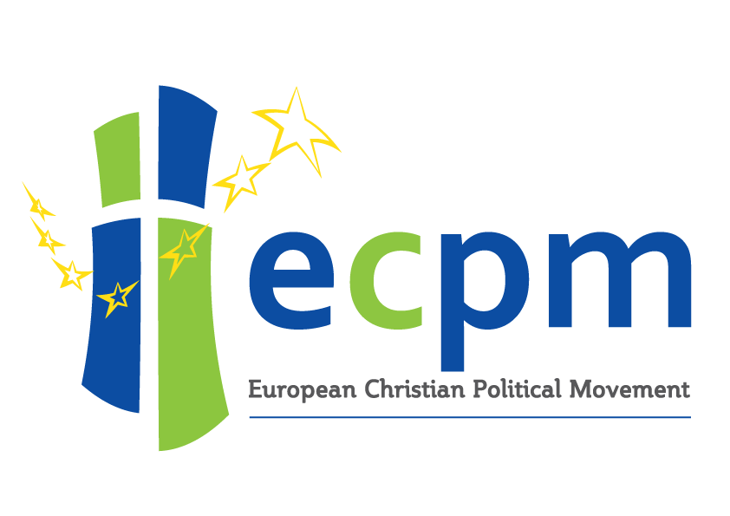

Basic programme for the ECPM

We are the members of the European Christian Political Movement (ECPM). This movement includes Christian-democratic and Christian-social parties, NGO’s and think tanks in Europe. We have come together to promote a Christian perspective on democracy. In our continent and the nations within it, we face growing problems. Neither the individualistic conservative-liberal nor the technocratic social-democrat approaches are able to give an adequate response or produce robust solutions.

People distrust political institutions and their work. There are growing tensions between different religious and ethnic groups in Europe. European nations are supporting each other less when we need solidarity to deal with our social, economic security and environmental problems.

We want to promote the Christian-democratic perspective on these 21st century questions. They affect individuals on their relationships in the community. They also affect our common responsibility for our society. We are convinced that Christian-social thought can generate political solutions. These can contribute to the well-being of the people of Europe. Christian-democracy made it’s contribution since it’s beginning in the 19th century with politicians like Groen van Prinsterer. Christian-democrats like Robert Schuman and Alcide de Gasperi laid in the 20th century the foundations of the European Union. We are convinced that Christian-democracy has also an important role to play in the 21st century.

The ECPM aims to spread these Christian Democratic ideas throughout Europe together with its social expression and to mobilize politicians and parties in Europe around Christian values. The source of these Christian values are the bible and the Christian tradition. These sources are in itself not a political program. These sources call us to serve the people of Europe and inspire us to work on a just government that pursuits justice, freedom, peace and a well-ordered society.

The basic teachings of Christian social thought appeal to everyone, irrespective of their faith, because it is founded on the pursuit of justice and liberty. If Christianity has shaped European civilization, it has done so in providing the institutions of justice, of education, of health, of help to the weak and the unfortunate.

The Christian understanding of the person

The Christian tradition understands the human person as a creation in the image of God, a spiritual being with a unique destiny, that is to be respected in its inviolable liberty and to be protected in vulnerable situations – is the source of the political balance and the social enrichment. It makes life in society a network of relationships.

The Christian-social view of society and government

A healthy society has a morale that results from mutual respect. The pursuit of private satisfactions should not interfere with our common duty to protect other members of society. On the other hand, the demands of the State or any other collective body, should not damage the rightful claims of the individual. This means that for a society to flourish it must create and nurture a spirit which respects the freedom and integrity of social and cultural institutions. It must encourage and nurture good relations between those institutions and people. Key social and cultural organisations include the family, school, religious organisations, and representatives of employees and employers. People build a society by developing their mutual relationships and becoming involved in communities and their common concerns.

The fundamental role of political authority is to ensure justice in the public realm. The state must create conditions that promote the common good and social connectedness. The exercise of power by the state must always be equitable and limited. The state must promote just relations between individuals, associations, communities, and other groups. The state must also respect their proper independence and interdependence.

Bearers of political authority are responsible to encourage the good, and rectify injustice. Governments are not required to attempt to remedy every social ill. Government must not undertake tasks that are the responsibility of family, church, or other spheres of authority. They should be able to deal with their own affairs. We believe that churches and other religious organisations can have an essential contribution to make in society.

Democratic participation enlarges the horizons of people. It empowers them as citizens and increases their influence on governments. A responsible democracy requires the expression of opinion through representative elections, political parties, public debate and loyal opposition. These together with respect for political office and open and accountable government are essential.

The responsibilities for public affairs should be at a level as close to the citizens as possible. This is our view at subsidiarity. We stand for this balance in power between the various nations and the European Union. We must protect national identity and respect the sovereignty of states. The European Union needs solidarity between nations and peoples. The European Union also needs subsidiarity to keep its solidarity alive. The ECPM recognises the different peoples of Europe.

No party or grouping may claim special legal privileges. Christian-democrat thinking strongly rejects secularism as a public ideology. The ECPM warns of the damage that fundamentalist secularism can inflict on a society. We are weary of such fundamentalist secularism in any kind of governing role. We also do not seek a governing role for any single church denomination. We recognise the role of the Christian faith in shaping the liberties that our continent enjoys. We affirm that the state needs to acknowledge the rights of religious and cultural minorities and to treat them equitably in public policy. We welcome the diverse faith communities present in Europe. Individuals, communities and organisations must have full freedom of religion and expression of thought. This must be a priority within Europe and in European foreign policy.

A Christian-democrat view of government will always have a global perspective. In this view all the earth is God’s creation, and God made all humans in his image. This means that Christian-democracy aims to have a foreign and defence policy that works in this spirit. It promotes fair trade as well as peace and protection of the environment.

We must not allow the state, business or finance to control the economy. Democratic responsibility requires this. The state should build up the contribution and sense of mutual responsibility of all parties. Economic activity is to serve people rather than dominate them. The full personal, social and ecological implications of national and international market activity need to be recognised and should not be merely a matter of private or accounting calculations that do not recognise these implications. The state must attempt to redress inequitable and unfair patterns of trade and distribution. Christian-democrats emphasise the state's responsibility for justice, right structures and social connectedness, rather than economic performance alone.

Basic themes in Christian-social policy

As Christian-democrats we do not imagine that we possess simple solutions to the problems of Europe. We do however firmly believe that Christianity can make an important contribution to the well-being of our society. For this reason, we commit ourselves to the following nine guiding principles which highlight some basic themes of Christian-social policy:

Justice

Social justice is a fundamental Biblical teaching. That makes it the basis for Christian-social policy.
All men and women are due equal respect and treatment. Men and women have responsibilities to one another and to wider society.
Social justice demands an equal regard for all. That implies a special concern for the needs of the poor, refugees, those who suffer and the powerless. It requires us to oppose exploitation and deprivation. It requires also that appropriate resources and opportunities are available. In this way, we meet the basic requirements of all and each person is able to take part in the life of the community.
We firmly believe that governments have a special responsibility for those who cannot support themselves in our own countries and abroad. Opposing and eliminating social injustice asks for more action by the government than only to provide just structures. It is also important to stress the need of healthy families, good education and health-care to prevent poverty and social injustice.

Respect for life and priority for the family

The right to life is the most basic among all the human rights. In the Christian tradition, every man and woman, as God’s creation, has an intrinsic value. Each person has the right to a respectable and dignified life from conception until natural death. In our view, the government is therefore obliged to:

Protect and promote the fundamental dignity of those that are not yet born, of the weak, of the physically and mentally handicapped, of people of old age, of all those that cannot stand up for themselves.
To have recognized by law in the entire European Union, the dignity and inviolability of the human embryo.
To support the family, founded in marriage, the complementarity between man and woman, the welcoming of life and the education of children. As cornerstone of society, a place where civic and social responsibilities are learned, the family should be the axis of political life, and all political sectors should be thought through in function of it and its equilibrium.

Reconciliation

Reconciliation is a task for individuals, social and economic groups, and also for those engaged in politics. We must work towards reconciliation and healing at local, national and international levels although we recognise that we will never achieve all such goals in this world.

Humility, repentance, patience and forgiveness are political as well as personal values. They are essential in the process of replacing conflict by common understanding. These principles require that we renounce all armaments that are incompatible with the pursuit of just peace.

Active Compassion

The Christian tradition calls human beings to active loving service of others. This is to replace indifference to the distress of others due to passivity, self-concern or ignorance. Such compassionate love inspires an attitude not only of detached justice but also of open-hearted generosity. We all bear the responsibility, individually and corporately, for such service to one another. Governments should seek to motivate individuals, families, charities and other associations to active compassion. The state should prompt and assist the community to meet the fundamental needs of the poor before satisfying the preferences of the rich.

Wise stewardship

The ECPM does not separate the responsibility of man towards the earth from his responsibility to himself. Faced with the extensive exploitation of natural resources, the wasting of non renewable energy and the tragedy of hunger and underdevelopment, the ECPM sees is the climate change an opportunity for a radical change of our approach to growth and international relations:

By means of policies of solidarity between the global North and South, aimed at reducing carbon gas emissions, by an increase in the production and use of clean energy, by restoring ecosystems; but also by promoting a balanced development that assures the access of all people to the essentials of life (food, drinkable water, education, health care… )
By means of Foreign policies and European defence policies that are aimed at promoting peace in service to a righteous development on the global scale.

Economy

In the Christian-social view, economic resources have to serve people's needs. This is vital in order to help in developing capacities particularly for justice, co-operation and mutual care. These resources should be used creatively and with responsible concern for others (including future generations) and the environment. Markets are not a law unto themselves. People shape them by their decisions. This means that we need to structure them so that those who conduct economic transactions are fair and do them in good faith. The needs of the community must be in mind.

Concentrations of wealth and power erode responsibility and may cause market distortion. We seek an economy where banks, businesses, trade unions, professional groups and government departments work together with greater mutual understanding and public accountability. Economic development is only a means. It should not dominate over social justice and protection of the environment.

The primary task of government in relation to the economy, is to oversee the establishment of just structures in all areas of economic activity. This kind of justice includes maintaining a sound currency against inflation or deflation. It encourages wealth creation by gainful employment. Christian-democrat parties discourage gambling and continuing dependency on state welfare provision. This is to encourage and equip all to participate fully in the economy. We need to use our communal and individual resources in a manner that respects the created order of the world.

Empowerment

Sometimes the accumulation of power may be necessary. This may be for the satisfactory performance of certain tasks. Undue power may also encourage patterns of control and domination. For this reason, it is wrong to assign to larger organisations what smaller and local associations can do adequately. We need to call to account those in whom much power is concentrated. Power concentrations may be with individual owners of wealth, professional interest groups, trade unions, multi-national corporations, national governments, or leaders of political blocs. They have great potential for working responsibly or irresponsibly, for or against the common good. They need to be held accountable for the exercise of their power.

People in Europe and beyond need to be empowered to be able to overcome poverty. Poverty often results from circumstances that are beyond the individual's control. They need to be able to participate in the decision-making process. People need to be educated. They need good literacy, numeracy and public services. People need these tools to restore their self-esteem and hope of possibilities. Governments can support individuals and communities in this process. Preventing corruption and
discrimination are important in this struggle for the wellbeing of all.

Final statement

We, Christian-democrats will promote our Christian-social values. We will do this in our own continent and beyond. We will try to implement Christian-democratic policies in our local, national and European political institutions.
We acknowledge the questions and challenges ahead. We look forward with trust and hope. Our Christian faith gives us a perspective that defies negativism and pessimism. This means that we are able to work in Europe and beyond, sharing Gods love in order to work for a better future.

